# Lab 12-Linux Programming with File System

## Tasks

* **Create a dialog box that takes filename from user then create .txt file on desktop of given filename.**

**Code:**

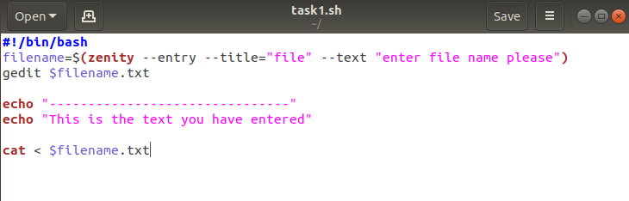

**Output:**

1. **Dialog box:**

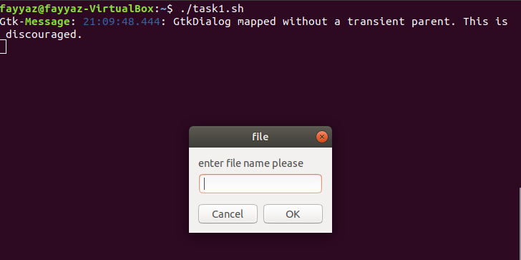

1. **Enter a filename on dialog box**

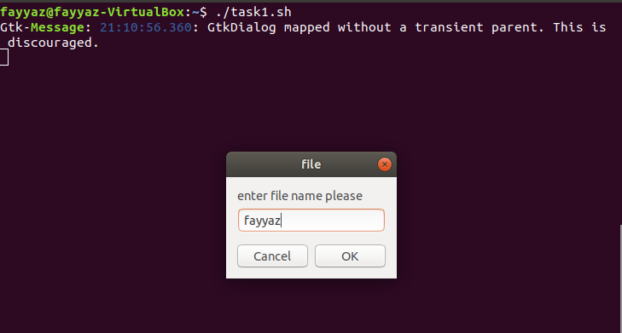

1. **Enter text on txt file:**

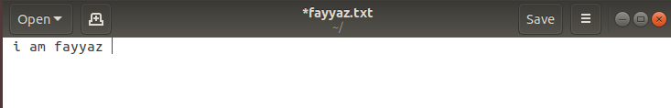

1. **Txt text print on output window:**

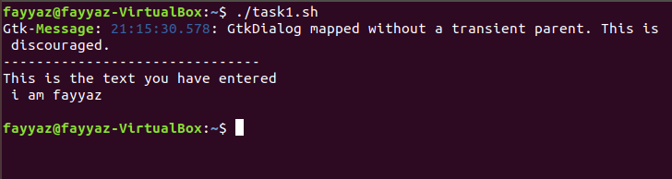

* **Write a program in shell zenity to ask from user his favorite color and display its favorite color in an info dialogue box.**

**Code:**

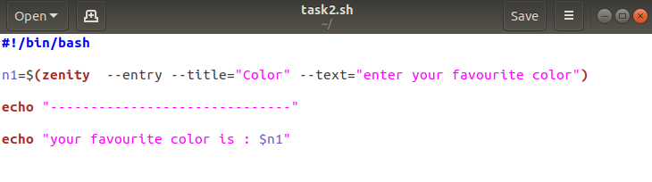

**Output:**

1. **Dialog box:**

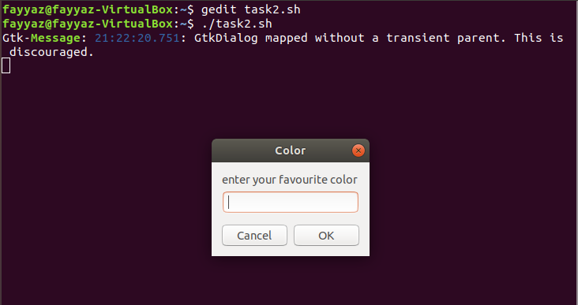

1. **Enter favorite color in dialog box:**

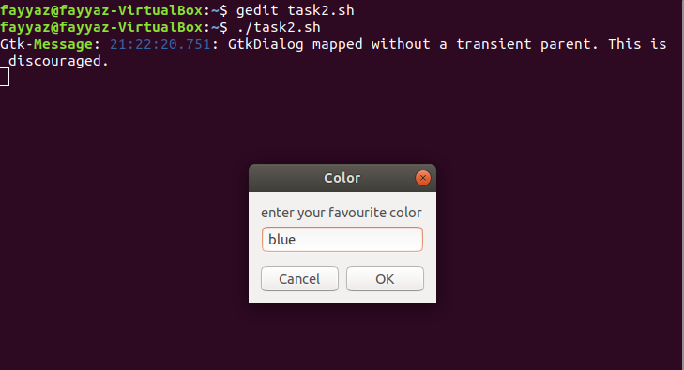

1. **Shell output:**

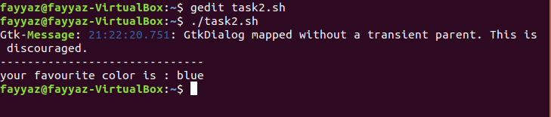

* **Create a graphical timer program i.e. ask a user to set time and display the info that the Time is up after the time completed. Use sleep for the time setting.**

**Code:**

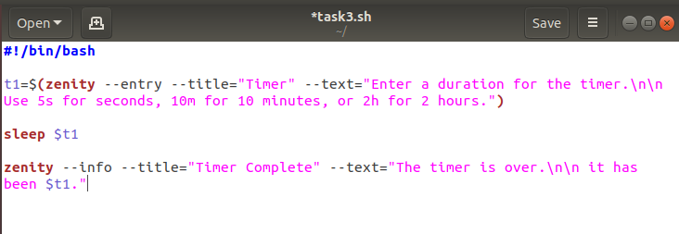

**Output:**

1. **Dialog box:**

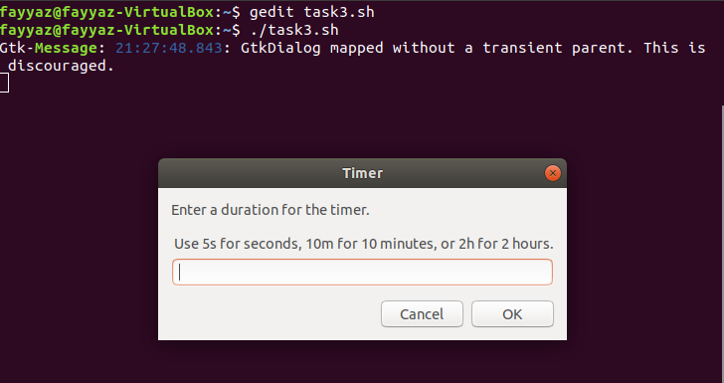

**2.Enter duration on dialog box:**

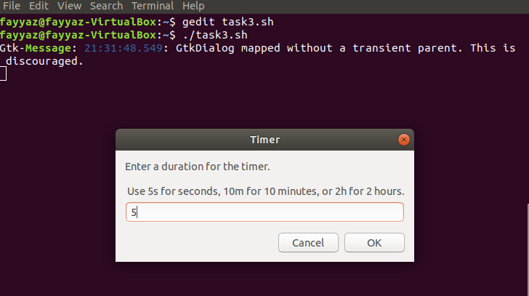

**After 5 seconds it occurs a message the timer is over:**

